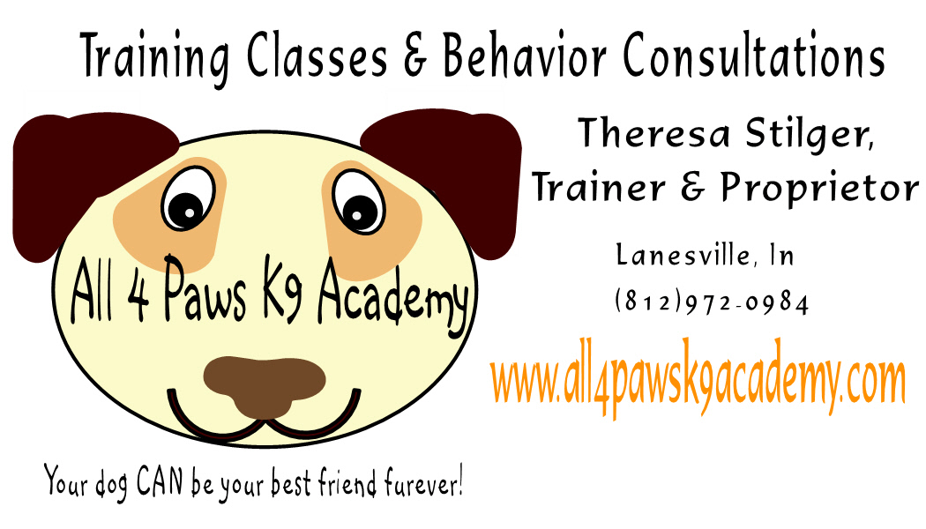

All 4 Paws K9 Academy General Release
and Agreement to Indemnify

I understand and acknowledge that participation in a dog obedience class is not without risk of injury to all persons and animals who may attend such a class, including the risk from exposure to animals which may be aggressive or difficult to control.

On behalf of myself, my pet, and any persons accompanying or substituting for me in the dog class offered by All 4 Paws K9 Academy referenced below (the “Class”) , I hereby release the All 4 Paws K9 Academy, the Lanesville Jaycees, all employees, directors, officers, members and agents from any and all damage resulting from the actions of any dog, including my own, or actions of any person, and I expressly assume the risk of any such damage or injury while participating in Class or otherwise on the property owned or used by the All 4 Paws K9 Academy.

In consideration of and as an inducement to the acceptance of my application for participation in the classes by the All 4 Paws K9 Academy, I hereby agree to indemnify and hold harmless the All 4 Paws K9 Academy, the Lanesville JayCees, all employees, directors, officers, members and agents from any and all claims, including claims for injury or damage by a person as a result of my actions or omissions, or the acts or omissions of my pet or the acts of omissions of any persons accompanying or substituting for me in a class.

______________________________________ ____________________________________
Participant’s Name (Please Print) Witness

______________________________________ ____________________________________
Signature of Participant (Signature of Legal Guardian for Minor Participant)

______________________________________ ____________________________________
Pet’s Name Date

